**Condition-Based Maintenance - Manufacturing Sector**

GOKULNATH K & E24755

**Overview**

Condition-Based Maintenance (CBM) in manufacturing relies on real-time data from sensors to monitor the health of equipment, predicting when maintenance is needed. It helps prevent unexpected failures by analyzing parameters like vibration, temperature, or pressure. This approach optimizes maintenance schedules, reducing downtime and extending machinery lifespan. Data analysis in CBM identifies patterns and trends, driving decisions on when to perform maintenance, enhancing operational efficiency.

**Objective**

1. **Predict Equipment Failures:** Use historical and real-time sensor data to identify patterns and predict when machinery is likely to fail, reducing unplanned downtime.
2. **Optimize Maintenance Schedules:** Develop data-driven models to determine the optimal time for maintenance, ensuring minimal disruptions to production.
3. **Enhance Asset Performance:** Analyze machine performance data to improve equipment efficiency, reducing wear and extending its operational lifespan.
4. **Reduce Maintenance Costs:** Leverage data insights to perform maintenance only when necessary, lowering costs associated with excessive servicing or emergency repairs.

**Assigned Task(s)**

* Condition-Based Maintenance - Manufacturing Sector

**Task Details**

* **Task 26 :** Condition-Based Maintenance (CBM) in manufacturing uses real-time data to predict equipment maintenance needs, minimizing downtime and optimizing performance. Data analysts leverage sensor data to identify patterns and schedule maintenance efficiently.
* **Status:** Completed.
* **Details:**

1. **Data Exploration:** Loaded and examined sensor data using Pandas to understand key statistics.
2. **Correlation Heatmap:** Visualized sensor data correlations with maintenance status using Seaborn.
3. **Data Visualization:** Created pair plots and boxplots to analyze sensor readings based on maintenance.
4. **Logistic Regression Model:** Built and trained a model to predict maintenance needs using temperature, vibration, and pressure.
5. **Model Evaluation:** Evaluated model accuracy and performance through classification reports.
6. **Prediction Visualization:** Compared actual vs. predicted maintenance status using scatter plots.

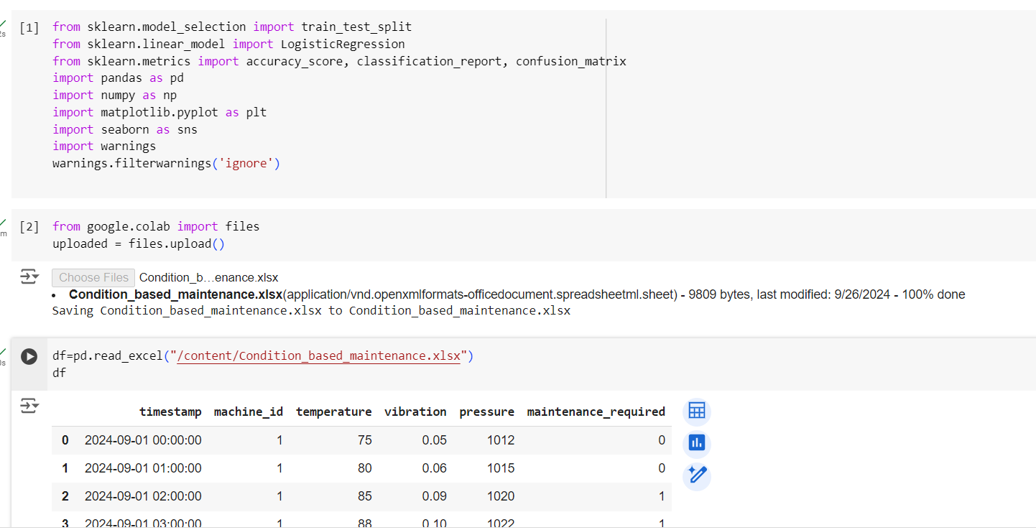

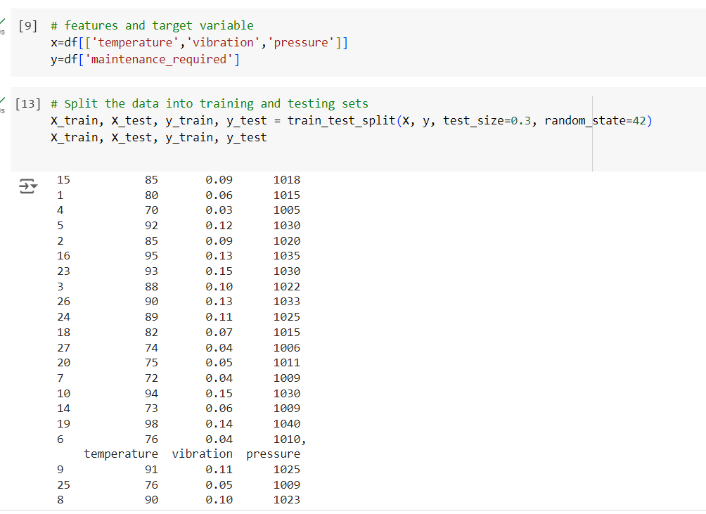

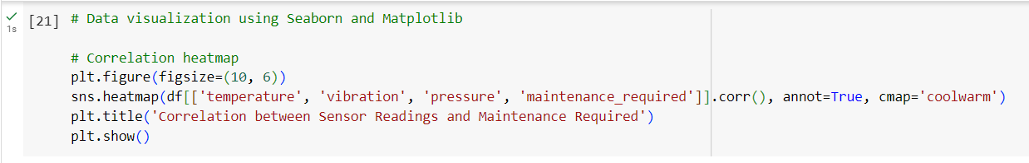

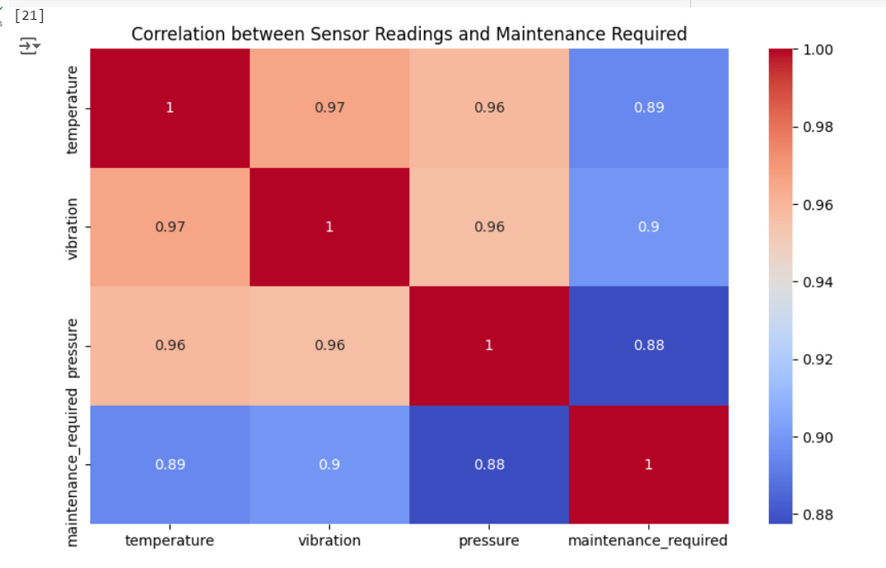

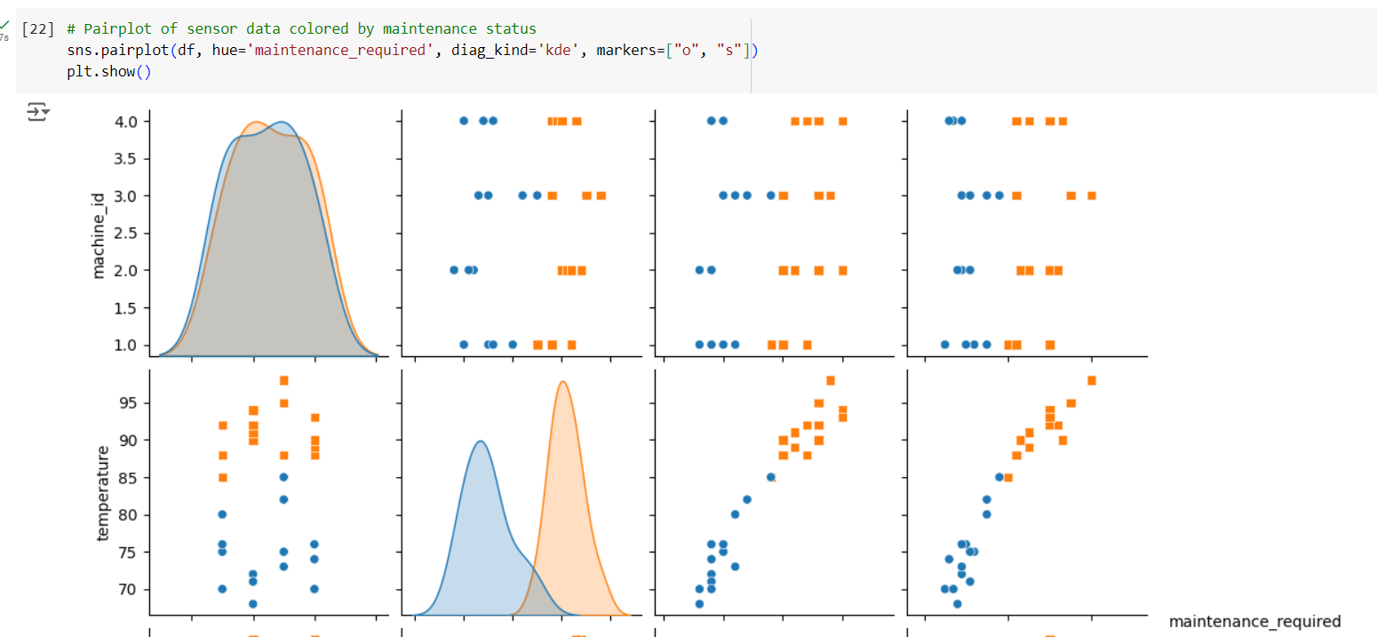

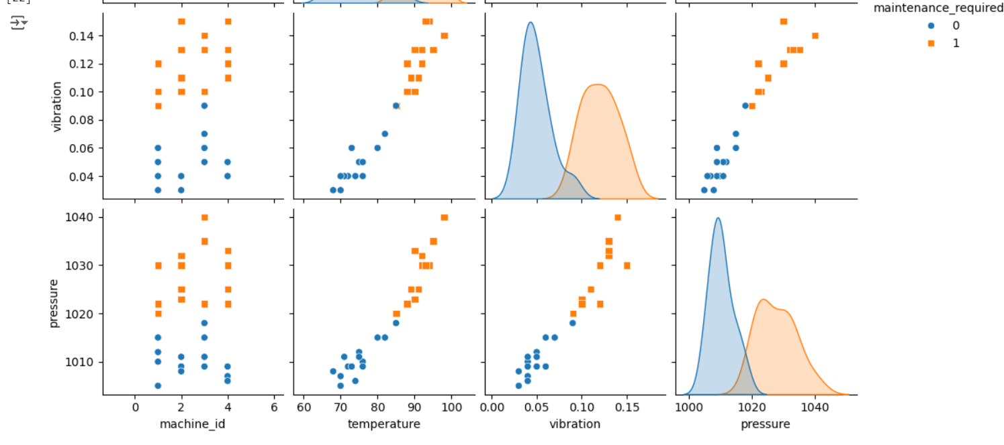

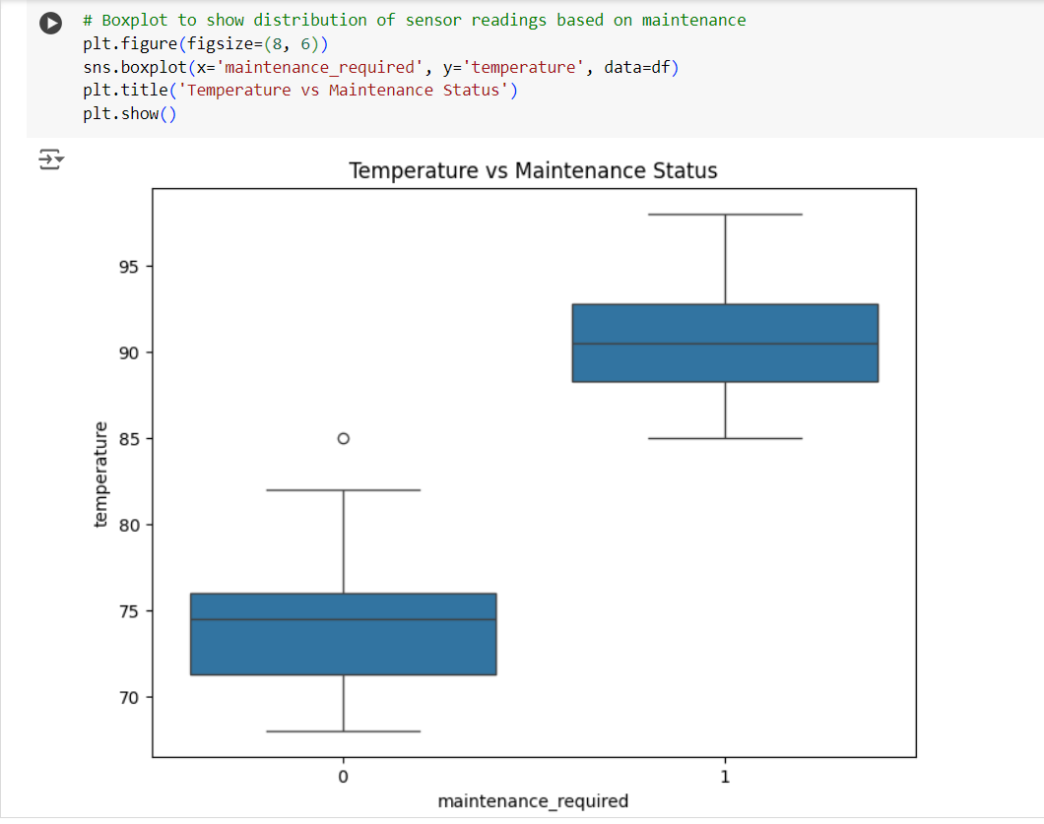

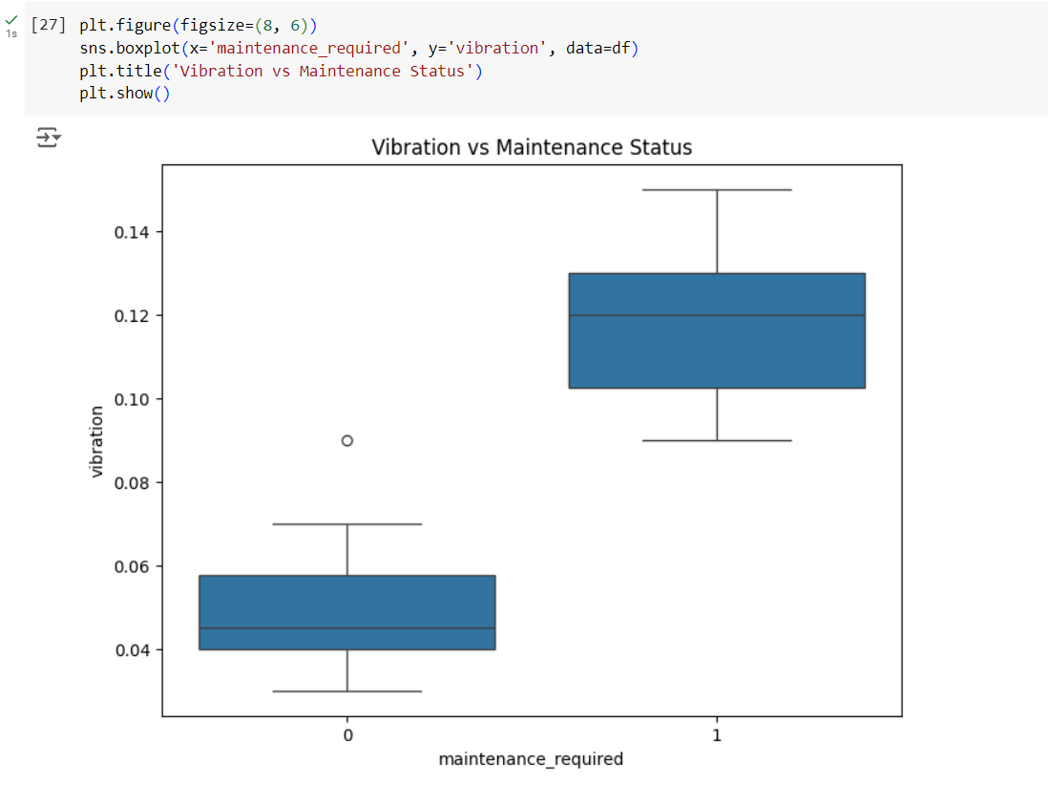

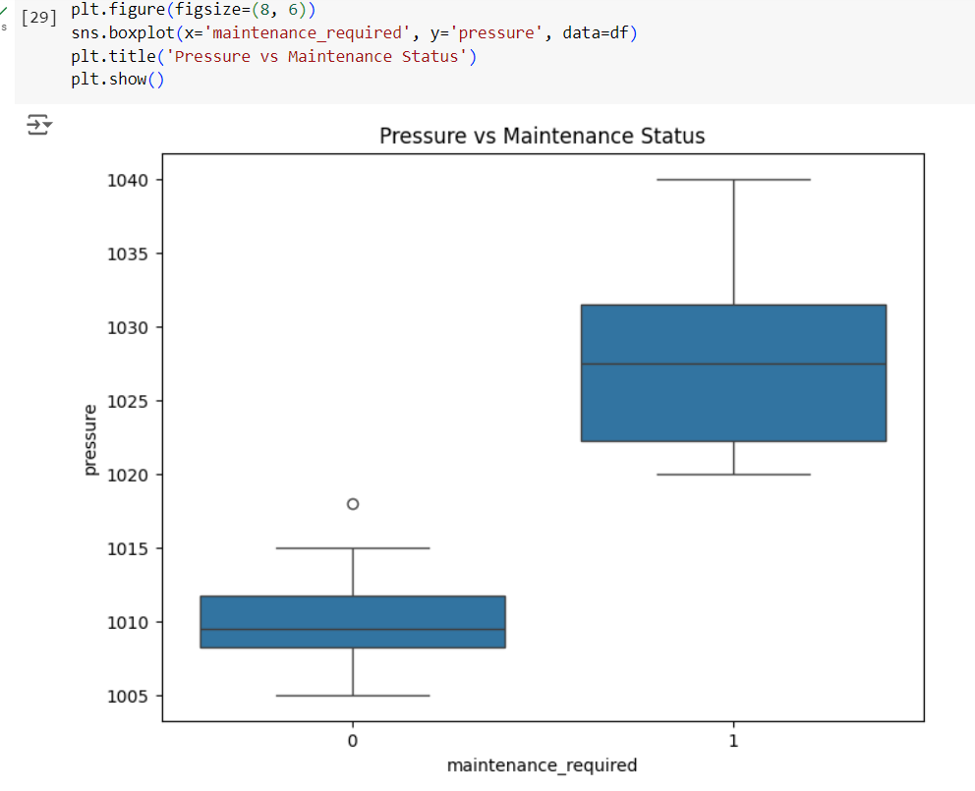

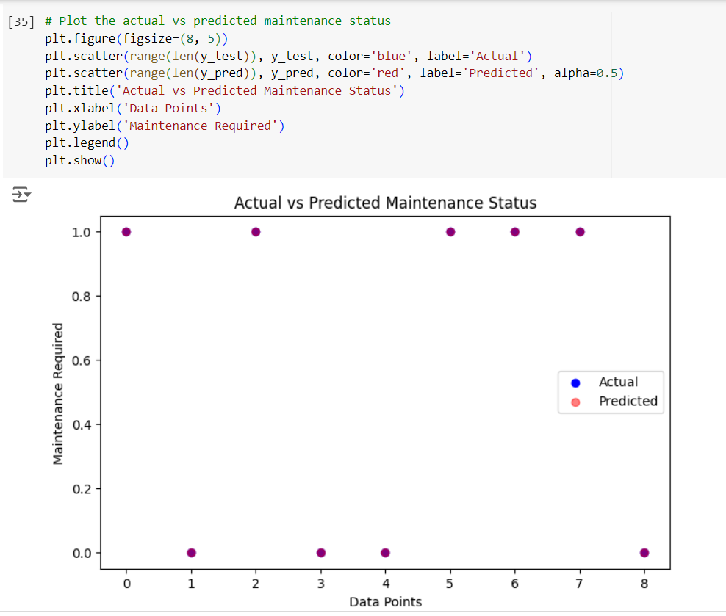

**Progress**

* **Accomplishments:**

1. **Optimized Maintenance Scheduling:** Successfully predicted maintenance needs, reducing downtime and improving machine efficiency.
2. **Enhanced Predictive Model:** Developed a logistic regression model using sensor data, achieving accurate predictions of machine failures.
3. **Data-Driven Insights:** Analyzed key factors (temperature, vibration, pressure) influencing maintenance decisions through correlation and visualization techniques.
4. **Improved Decision-Making:** Provided actionable insights for maintenance teams, leading to proactive machine servicing.
5. **Reduced Maintenance Costs:** Prevented unnecessary maintenance by accurately predicting when intervention is required.

* **Metrics:**

1. **Prediction Accuracy:** The percentage of correct predictions made by the logistic regression model for maintenance needs.
2. **Downtime Reduction:** The decrease in machine downtime due to timely maintenance predictions.
3. **Maintenance Frequency:** The number of maintenance actions predicted vs. actual interventions.
4. **Cost Savings:** Reduction in maintenance costs by preventing unnecessary interventions.
5. **Failure Detection Rate:** Percentage of actual machine failures correctly predicted by the model.

**Challenges and Solutions**

* **Challenges Faced:**

1. **Data Quality Issues**: Inconsistent or incomplete sensor data can affect analysis accuracy.
2. **Sensor Data Overload**: Handling large volumes of real-time data from multiple sensors can be complex.
3. **Feature Selection**: Identifying the most relevant variables (temperature, vibration, pressure) that influence maintenance decisions.
4. **Model Accuracy**: Ensuring predictive models are accurate enough to prevent both false alarms and missed maintenance events.
5. **Integration with Operations**: Aligning predictive insights with actual maintenance schedules and operations.

* **Solutions Implemented:**

1. **Data Cleaning:** Applied data preprocessing techniques to clean and standardize the sensor data for analysis.
2. **Data Filtering:** Used aggregation and filtering techniques to handle and process large sensor datasets efficiently.
3. **Correlation Analysis:** Utilized correlation matrices and visualizations to identify the key factors affecting maintenance.
4. **Model Tuning:** Improved prediction accuracy by tuning logistic regression parameters and using advanced evaluation metrics.
5. **Actionable Reporting:** Created clear reports and visualizations to integrate CBM insights into practical maintenance schedules.

**Next Steps**

* **Upcoming Tasks:** To face upcoming tasks in the Manufacturing sector, focus on improving data integration, enhancing model accuracy, and aligning predictive insights with real-time operations for proactive decision-making.
* **Goals:** To achieve upcoming goals in the Manufacturing sector, prioritize optimizing predictive models, leveraging advanced analytics, and enhancing collaboration between data insights and operational teams.

**Conclusion**

* **Summary:** Condition-Based Maintenance (CBM) leverages sensor data and predictive modeling to optimize maintenance scheduling and reduce machine downtime. By addressing challenges like data quality and model accuracy, data analysts can provide actionable insights that improve operational efficiency. Continuous enhancement of models and data integration will further strengthen maintenance strategies.
* **Acknowledgments:** Thank you all for your time and attention, and I look forward to any questions or discussions.